**DAILY ONLINE ACTIVITIES SUMMARY**

|  |  |  |  |  |  |  |  |
| --- | --- | --- | --- | --- | --- | --- | --- |
| **Date:** | **29/06/2020** | | | **Name:** | | **K. ISHA HEGDE** | |
| **Sem & Sec** | **4th SEM 'A' Section** | | | **USN:** | | **4AL18CS031** | |
| **Online Test Summary** | | | | | | | |
| **Subject** | | N/A | | | | | |
| **Max. Marks** | | N/A | | | **Score** | N/A | |
| **Certification Course Summary** | | | | | | | |
| **Course** | **INTRODUCTION TO HADOOP** | | | | | | |
| **Certificate Provider** | | | **GREAT LEARNING.** | | **Duration** | | **3 hour** |
| **Coding Challenges** | | | | | | | |
| **Problem Statement:** 1. Given a list of numbers, write a Python program to count Even and Odd numbers in a List.  .  For example | | | | | | | |
| **Status: completed** | | | | | | | |
| **Uploaded the report in Github** | | | | | **Yes** | | |
| **If yes Repository name** | | | | | <https://github.com/iishaii/locked-down_coding> | | |
| **Uploaded the report in slack** | | | | | **Yes** | | |

Certification Course Details: (Attach the snapshot and briefly write the report for the same)

Coding Challenges Details: (Attach the snapshot and briefly write the report for the same)

**CERTIFICATION COURSE SUMMARY:**

Today I started new course INTRODUCTION TO HADOOP in Great Learning which is of 8 hrs. After the completion of course, certificate will be provided.

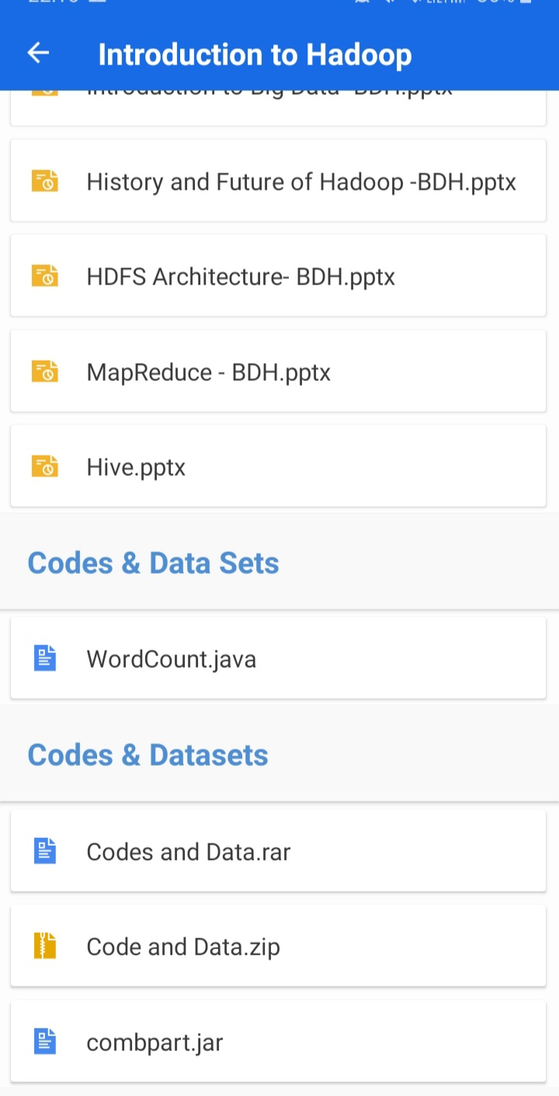

**CODING CHALLENGES DETAILS:**

1. Given a list of numbers, write a Python program to count Even and Odd numbers in a List.

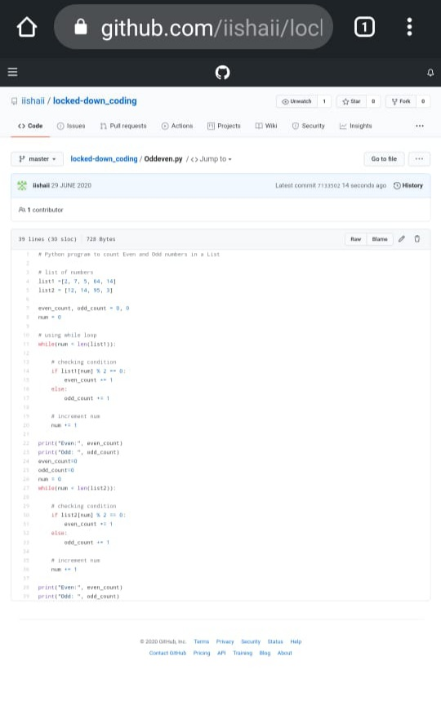

**EXTRA ACTIVITIES**:

Today I have attended the webinar on "Cybersecurity” by HOD Mr.Manjunath Kotari, CSE department, AIET. The session was very interesting. There was assessment conducted based on the webinar.

